Accessing and using your Microsoft Office Outlook Email
- Open your internet browser and in the address bar, type in “office.com” and then hit “Enter” on your keyboard.
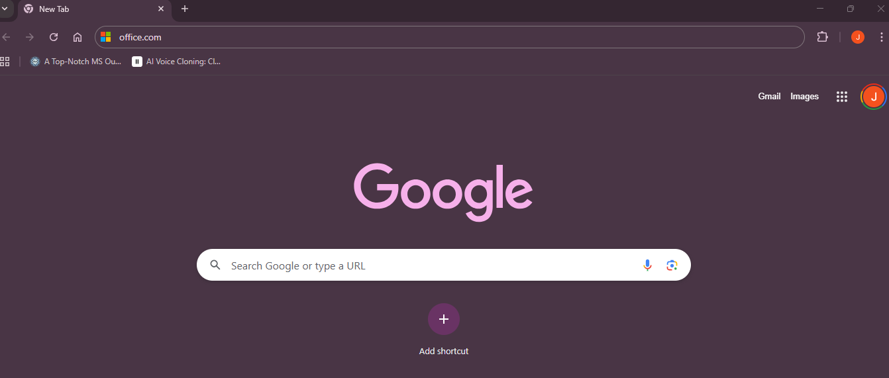
- Click on “Sign in”.
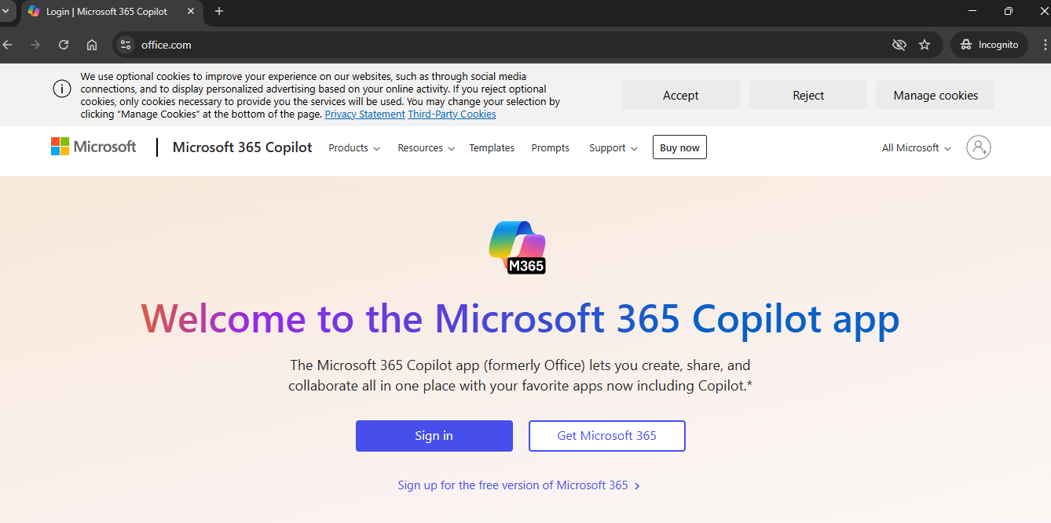
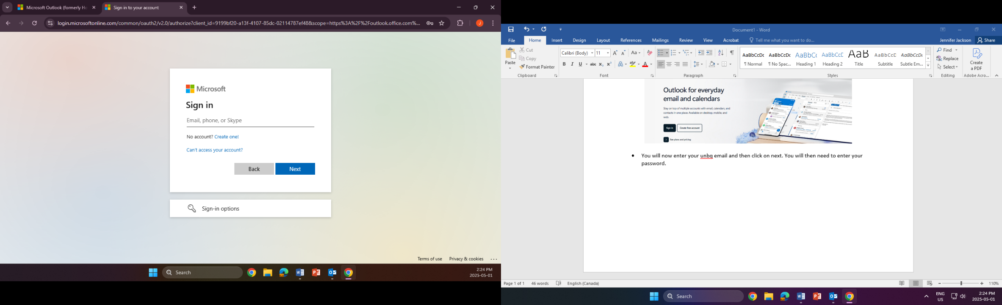
- You will now enter your unbq email (firstname.lastname@unbq.ca) and then click on next.

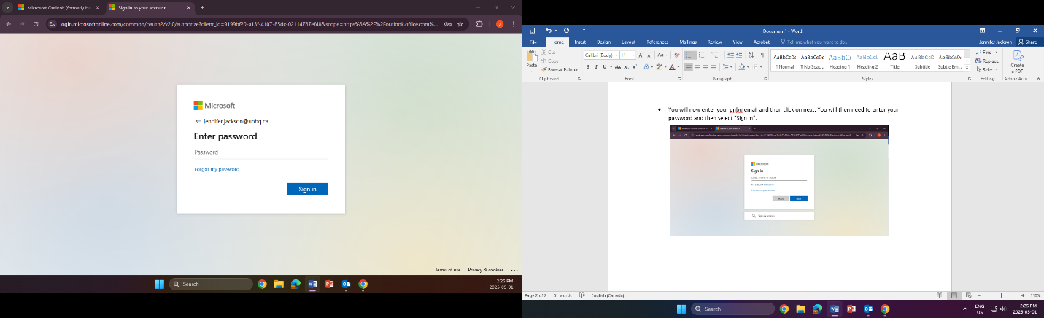
- You will then need to enter your password and then select “Sign in”.

*You will then be prompted to “Stay signed in?”. If you are using your personal computer, you may click “Yes”. If you are on a shared computer, you must click on “No”. After you click on either “Yes or No”, you will be brought to your Outlook email.
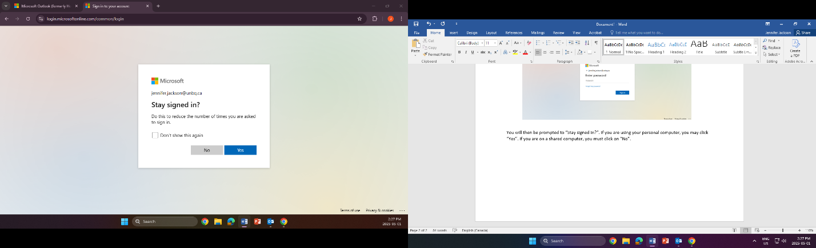
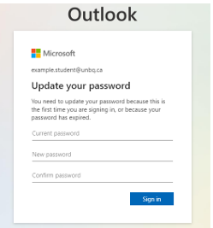
If this is the first time you have signed in you will be prompted to update your password. Enter your current password Earth01$

Then enter the password of your choice. You will need to enter the new password twice. Click on Sign In
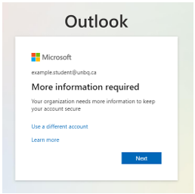
The information you will provide in this next step allows you to reset your password if needed. Click on Next

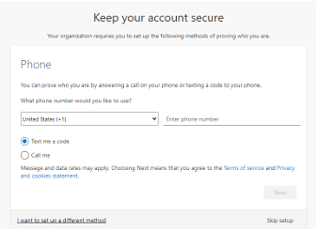
You will need to change from United States to Canada and enter your phone number. You can choose to receive your verification code by text or call.
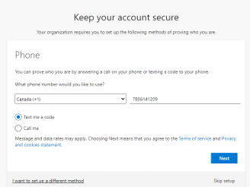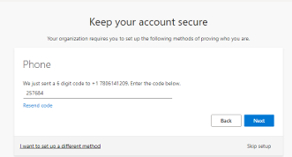

Enter the verification code you receive and click on Next. You will see the message below if successful
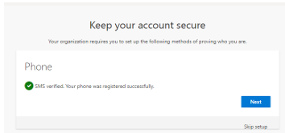
Click on Next, you have registered your phone.
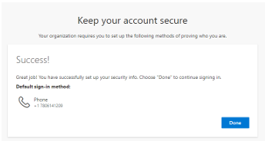
You have completed the verification process. Click on Done You will be asked if you wish to stay signed in. If you are using your personal computer, it is okay to stay signed in. If you are using a computer at Blue Quills please do not stay signed in.
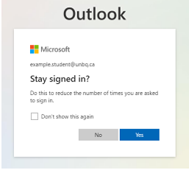
You have now signed into Office.com.

Once you have signed into office.com, you should see the co-pilot screen below.
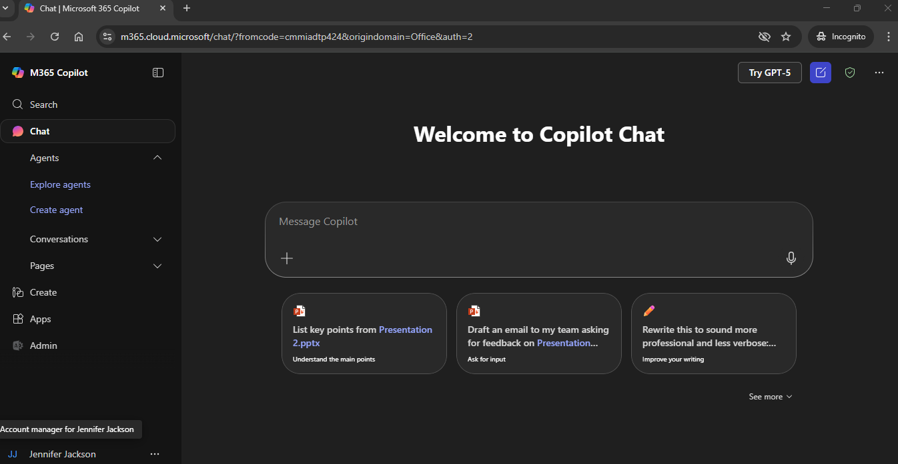
To locate your email, click on “Apps” (indicated by the blue arrow) and then click on “Outlook” (indicated by the yellow arrow) in the picture below.
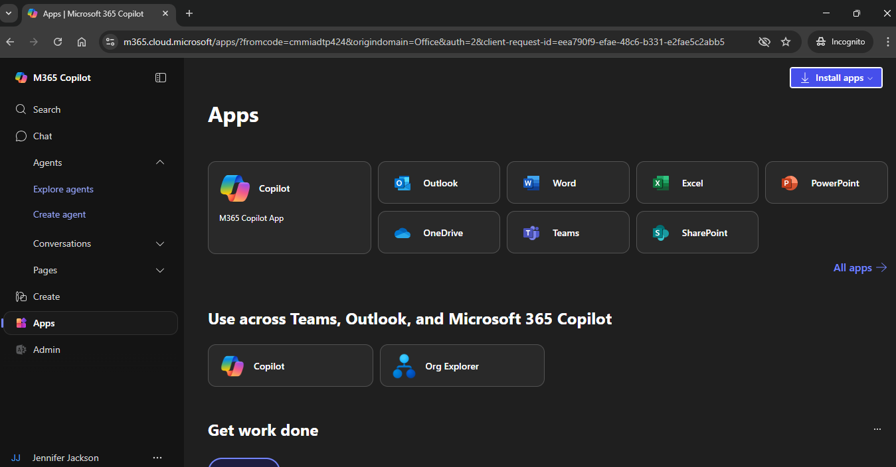
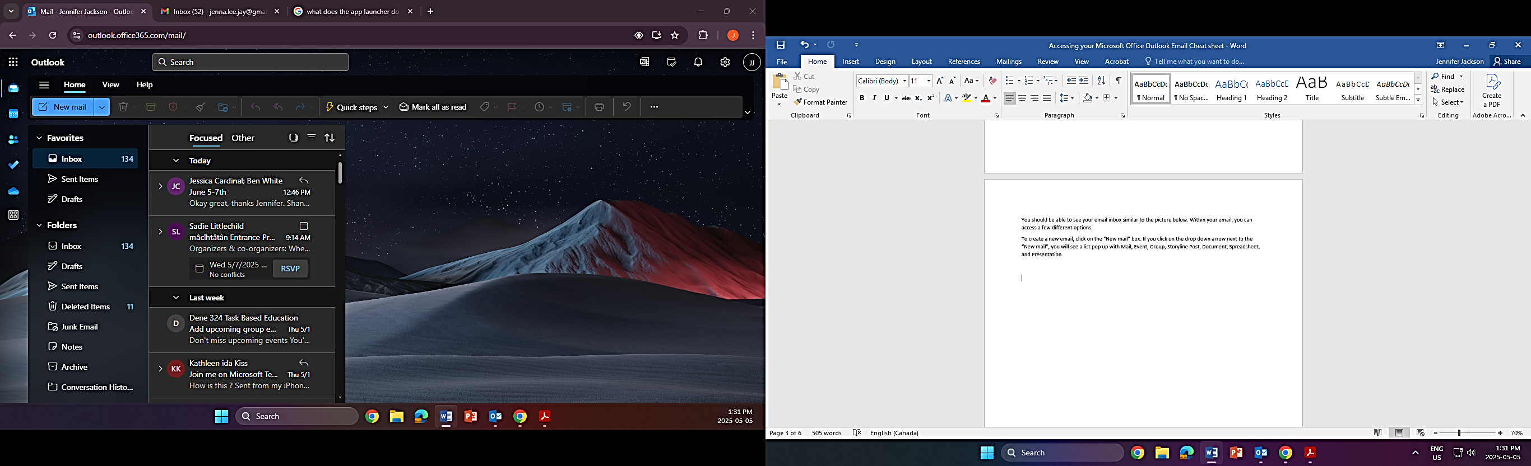
You should be able to see your email inbox similar to the picture below. Within your email, you can access a few different options.

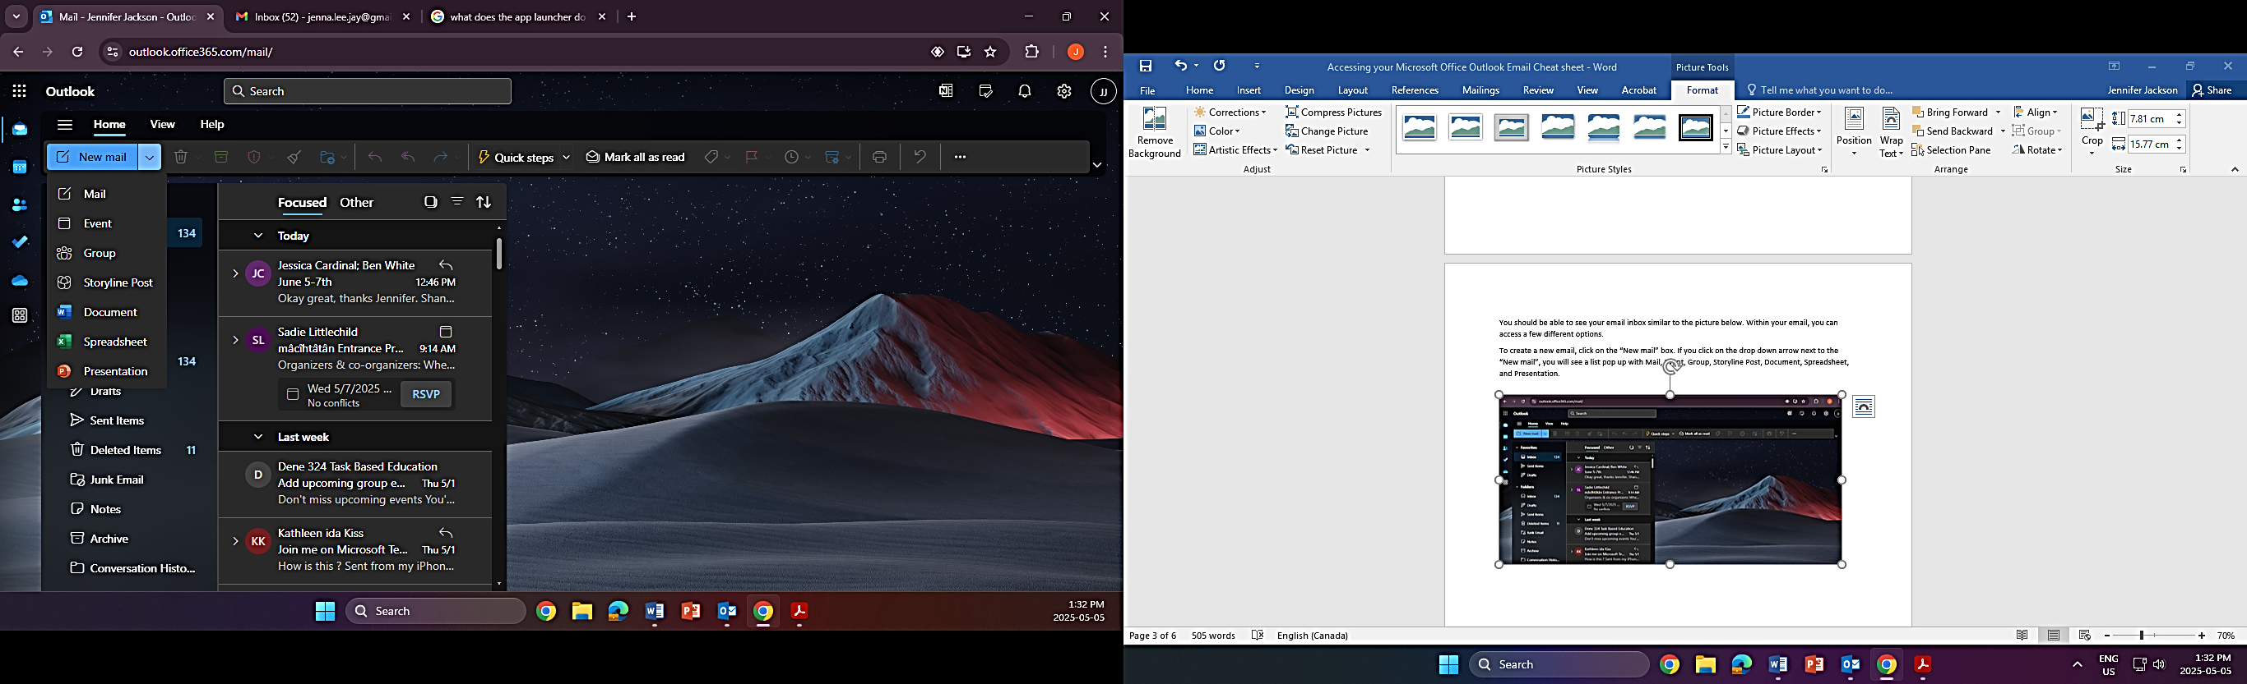
To create a new email, click on the “New mail” box. If you click on the drop down arrow next to the “New mail”, you will see a list pop up with Mail, Event, Group, Storyline Post, Document, Spreadsheet, and Presentation.

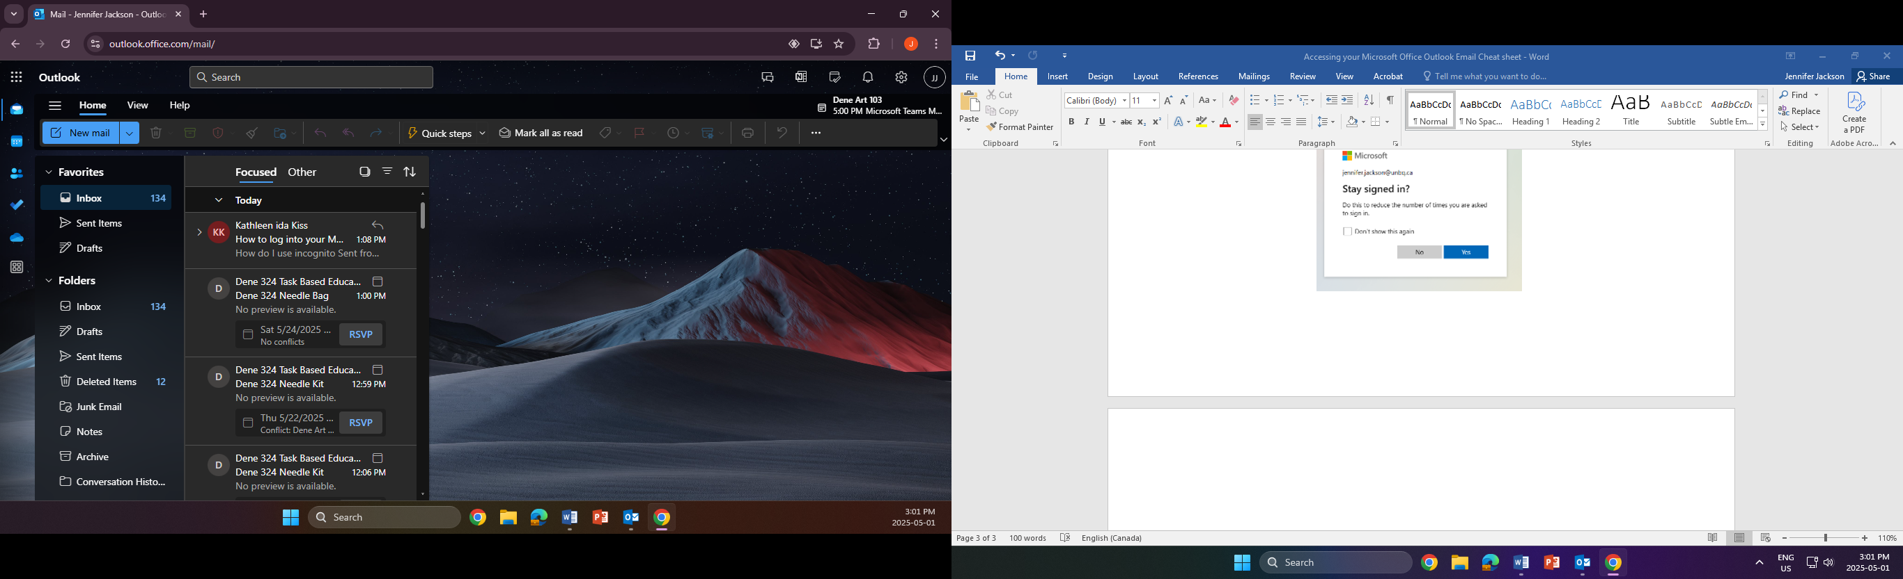
In the picture below, in the highlighted yellow section, you will see a few different icons (from top to bottom); the app launcher, mail, calendar, people, to do, one drive and more apps. Descriptions of this list are below the picture.
- The “App Launcher” is a navigation tool that provides users with a central location to access all their Microsoft cloud services, including Outlook, Word, Excel, and more. It essentially acts as a dashboard, allowing users to switch between different apps within the Microsoft 365 suite with ease.
- The "Mail" section primarily manages your email communication. It allows you to create, send, receive, and manage emails, including attachments, signatures, and organizing your inbox with folders and rules.
- The “Calendar” helps users manage their schedules by allowing them to create and organize appointments, meetings, and events. It also enables sharing and delegating calendar access, as well as viewing group calendars. Key features include reminders, color-coding, and integration with other Microsoft 365 apps.
- The "People" section, or the People page, is used to manage and interact with contacts, contact lists, and groups. Users can create, view, edit, and even delete contacts, as well as organize them into groups. It also allows for creating and managing groups, which can be used to streamline communications within specific teams or projects.
- The "To Do" is a task management feature that allows you to create and manage to-do lists, including daily lists, important items, and flagged emails.
- OneDrive enables easy sharing of files stored in the cloud. It allows users to share files attached to emails as links, instead of sending copies, which streamlines collaboration and reduces file clutter. OneDrive also provides features for file recovery and version history.
- the "More Apps" group organizes and consolidates apps, allowing users to access them without cluttering the main sidebar.

In the highlighted blue section, you will see (from left to right) “Focused” “Other” “Select” “Filter” and “Sorted: By Date”. These options assist with filtering your Inbox. Be mindful to check both “Focused” and “Other” as information is stored in both. Descriptions of this list are below the picture.

  - The “Focused” tab contains your most important email messages
  - The “Other” tab holds the rest, allowing you to prioritize your inbox
  - If you click on Select, you will see that boxes appear on each email. This allows you to select either one or more emails at a time to either move the messages to another folder or to send them to the trash.
  - If you select the Filter option, you will then be able to set up your inbox to show All emails, Unread emails, Flagged emails, emails sent directly to you, emails that have attached files, emails that mention you within them and emails that have calendar invites. Be mindful when you use the Filter option. If you do not set it back to “By date”, you may miss some emails as your inbox is still filtering.

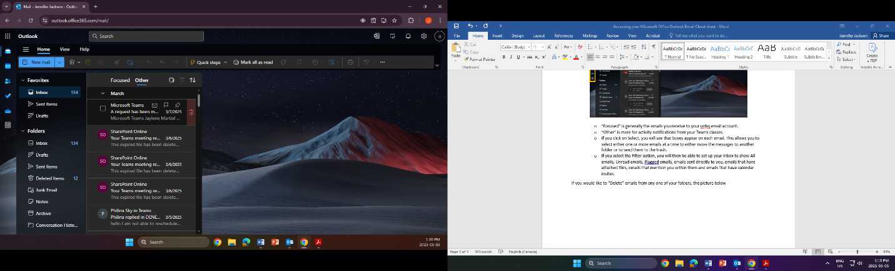
If you would like to “Delete” emails from any one of your folders, the picture below shows you where you can find the delete option. Place/hover your mouse/curser over the email you would like to delete. You will see a trash bin appear on the right side of your email. Click on the trash bin and your email has been sent to your “Deleted Items” folder.

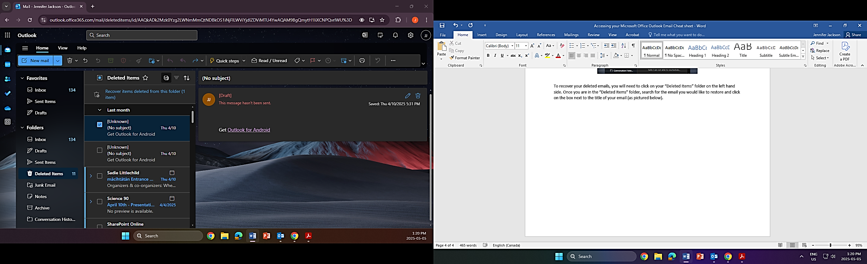
To recover your deleted emails, you will need to click on your “Deleted Items” folder on the left hand side. Once you are in the “Deleted Items” folder, search for the email you would like to restore and click on the box next to the title of your email (as shown by the blue arrow). You will then click on the “Move to a folder” icon on the menu bar above (as shown by the yellow arrow) and then click on “Inbox. This will restore your deleted email back to your Inbox.
When you are finished looking at your email and want to sign out, click on the circle with your initials in the upper right corner and select Sign Out (indicated by the blue arrow in the pictures below).
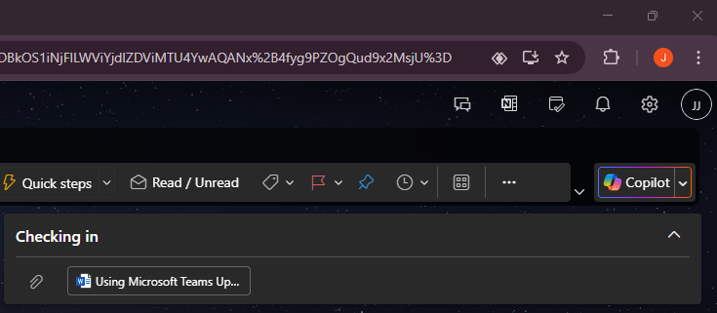
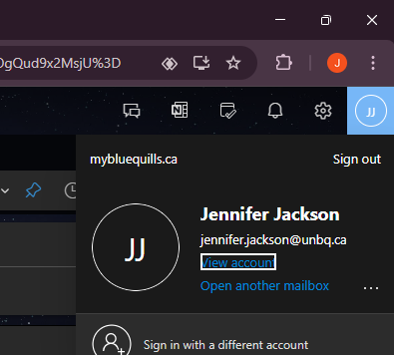

If your screen looks like the picture below, you have successfully signed out of your email account.
